Perovskite Solar Cells Based on Metal-ion-linked Self-Assembled Monolayer (MiLSAM)
Wei Zhou ª, Zhijun Ningª*

ªSchool of Physical Science and Technology
Email: ningzhj@shanghaitech.edu.cn

Abstract
In recent years, self-assembled monolayers as hole-selective contact layers have advanced the efficiency of inverted perovskite solar cells. However, their non-uniform coverage on metal oxide electrodes can lead to interfacial carrier recombination, a problem that is particularly pronounced in large-area devices. Meanwhile, the tendency of these molecules to desorb under photothermal stress also affects the operational stability of the devices.
In this study, we introduce a metal-ion-crosslinked self-assembled molecular layer as a robust hole-selective contact layer to address these challenges. Through an alternating assembly method, a molecular network was constructed using high-valence metal ions as crosslinking nodes. The resulting metal-ion-crosslinked self-assembled molecular layer not only achieved uniform substrate coverage but also exhibited enhanced stability against surface reconstruction.
Inverted perovskite solar cells employing this molecular layer achieved a power conversion efficiency of 26.71% with a certified efficiency of 26.46%, while 1 cm² devices delivered a record efficiency of 25.75%. Encapsulated devices based on this strategy demonstrated excellent thermal stability: they retained 91% of their initial efficiency after 2,000 hours under conditions close to ISOS-D-3 testing conditions (85°C, 85% relative humidity), and retained 90% of their initial efficiency after 1,000 hours of maximum power point tracking under conditions close to ISOS-L-3 testing conditions (85°C, 50% relative humidity). This work provides a viable pathway for simultaneously enhancing the stability and efficiency of perovskite solar cells.
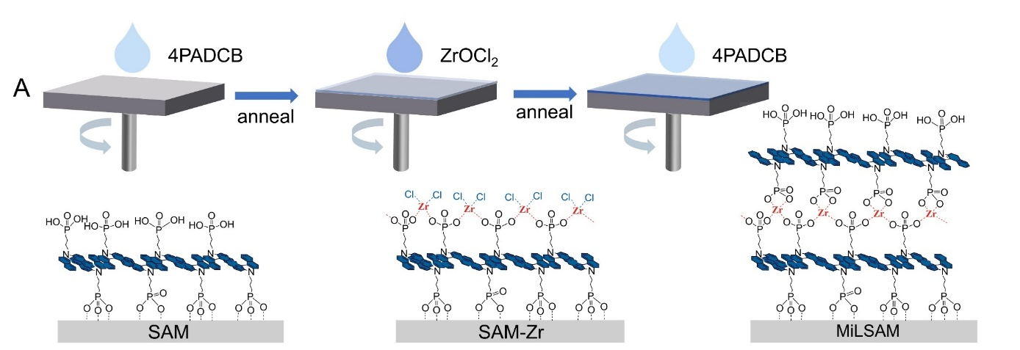
Fig. 1 Schematic of MiLSAM

References
- Wei Zhou, Wenzhuo Li, Hao Chen, Mingyu Ma, Minyong Du, Junhan Xie, Zhiyi Yao, Chenglong Ge, Haobo Wu, Xin Wen, Yuedong Shi, Chengwu Ouyang, Wenjing Wang, Weixuan Liu, Gaoqi Liu, Hao Liang, Peihong Cheng, Wenjia Zhou, Erkan Aydin, Mingyang Wei, Weimin Liu, Zhijun Ning*. Chem. 2026, 12, 102965.

